

**OpenHome**

**A Project Report**

**Presented to**

**Prof Charles Zhang,**

**Faculty of College of Engineering**

**Presented By:**

1. Chintala Dheeraj Dharma(013760968)
2. Manish Katturu  (013825201)
3. Sayali Patil (013530439)
4. Surabhi Sinha (013704652)

Table of Contents

1. Introduction 3

2. Bonus Features 3

2.1. Export Survey 3

2.2. Import Survey 5

3. Design and Architecture 7

3.1. High Level Components Architecture 7

3.2. Database Design 8

4. Technologies 8

5. Screenshots 9

5.1. Signup 9

5.2. Login 10

5.3. Survey Dashboard 11

5.4. Create Survey (Survey Builder) 11

5.5. Share Survey 13

5.6. Survey Response 14

5.7. Survey Statistics 17

6. Testing Plans 21

6.1. Black-Box Testing 21

6.2. Server Unit Testing 22

7. Retrospect and Future Enhancements 26

8. Github URL 26

9. Application URL 26

# Introduction

**Motivation:**

The motivation here was to develop a platform to create, edit and give surveys and where a user can create or invite participants to surveys with variety of options of accessibility like general, open and closed surveys. We analysed the requirements of the project, brainstormed on its design, made choices of technology, Modelled the design using UML, designed the database and used Agile methodology for development.

**Introduction:**

Survey is an enterprise survey management system with a facility to create, edit, publish, save and take surveys. The Application starts with user registration and email verification using a verification code sent to mentioned email address. Registered users can assume roles of both surveyor and surveyee. As surveyors, users can choose to create a survey, name it, give it a type from general, closed and open, put an expired date optionally, add various types of questions with their plain text or images as options, save the survey to edit it later, publish the survey, invite participants to take the survey and see what surveys has the user been invited to give. A surveyee can take the survey, submit the survey, choose to get an email confirmation for completing the survey and revisit the link to see the response.

# Design and Architecture

# High Level Components Architecture

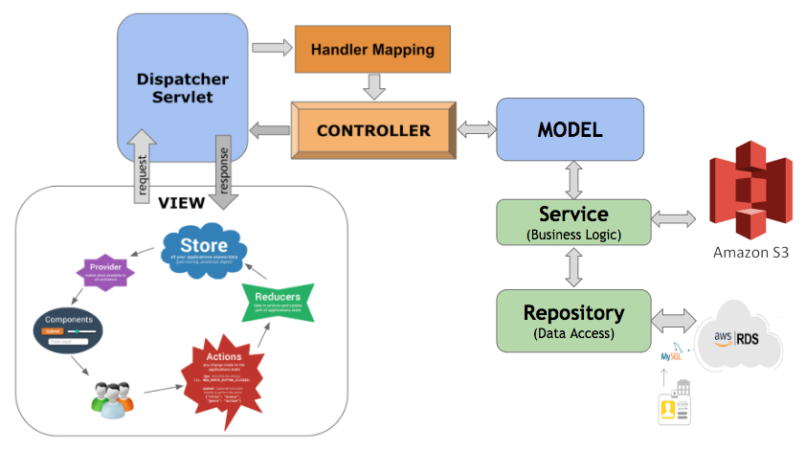

RESTful Web Application is developed using React as front-end. Also used Redux to maintain state at global level. Used Spring Boot to develop server in which REST Controller were developed to create REST connection with React. Used concept of AOP to verify Session for activities that are only authorized to logged in users. Used MySQL Database of AWS RDS to have centralized database and also being a RDBMS MySQL supports spring boot’s JPA functionality. Created AWS S3 bucket for storing images for multiple choice questions. React is deployed on EC2 Instance and Spring Boot Server is deployed on another EC2 Instance.

# Database Design

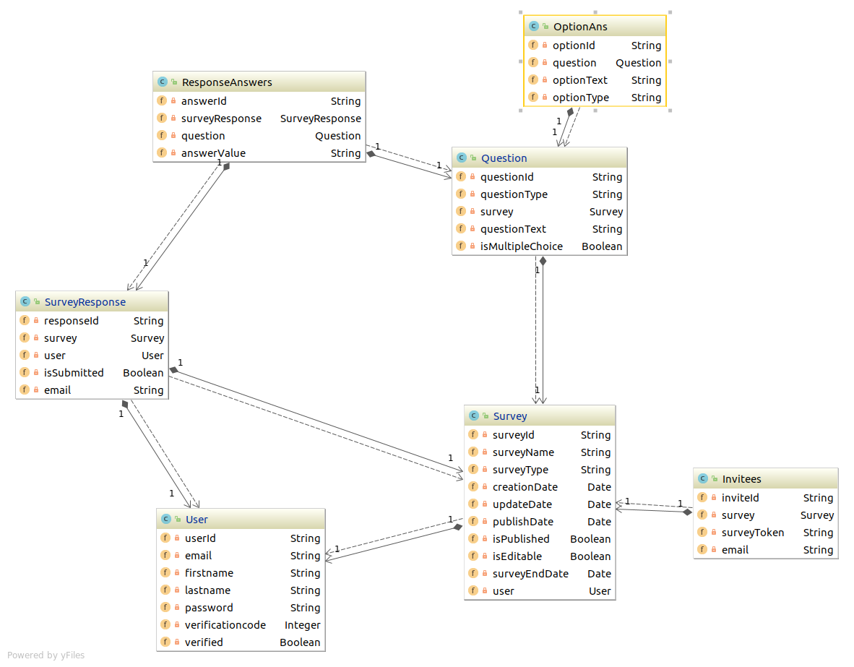

# Technologies

* Client:
  + React – Redux
* Server:
  + Spring Boot
    - ORM
    - JPA
    - Hibernate
    - AOP
* Database:
  + AWS RDS MySQL
* Image Data Storage:
  + AWS S3 Bucket
* Deployment
  + AWS EC2 Instances
    1. Client Instance (React)
    2. Server Instance (Spring Boot)

# Screenshots

# Signup

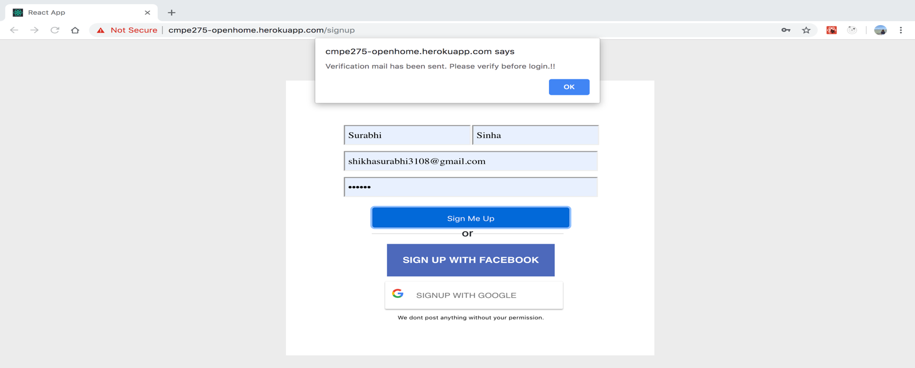

* Email received to verify account

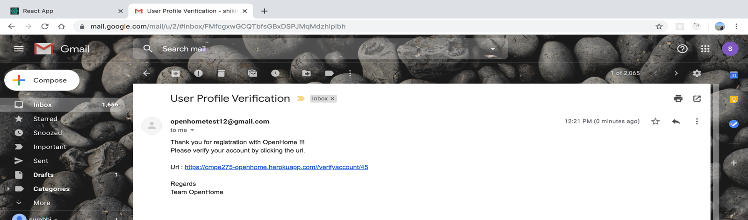

* User can click on the link in email to verify and will get success message

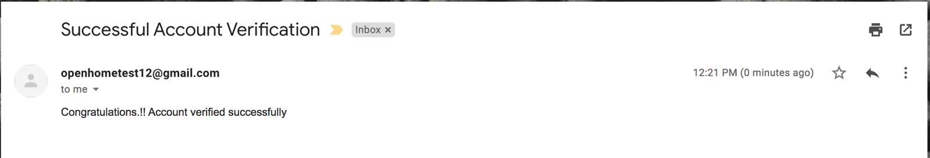

# Login

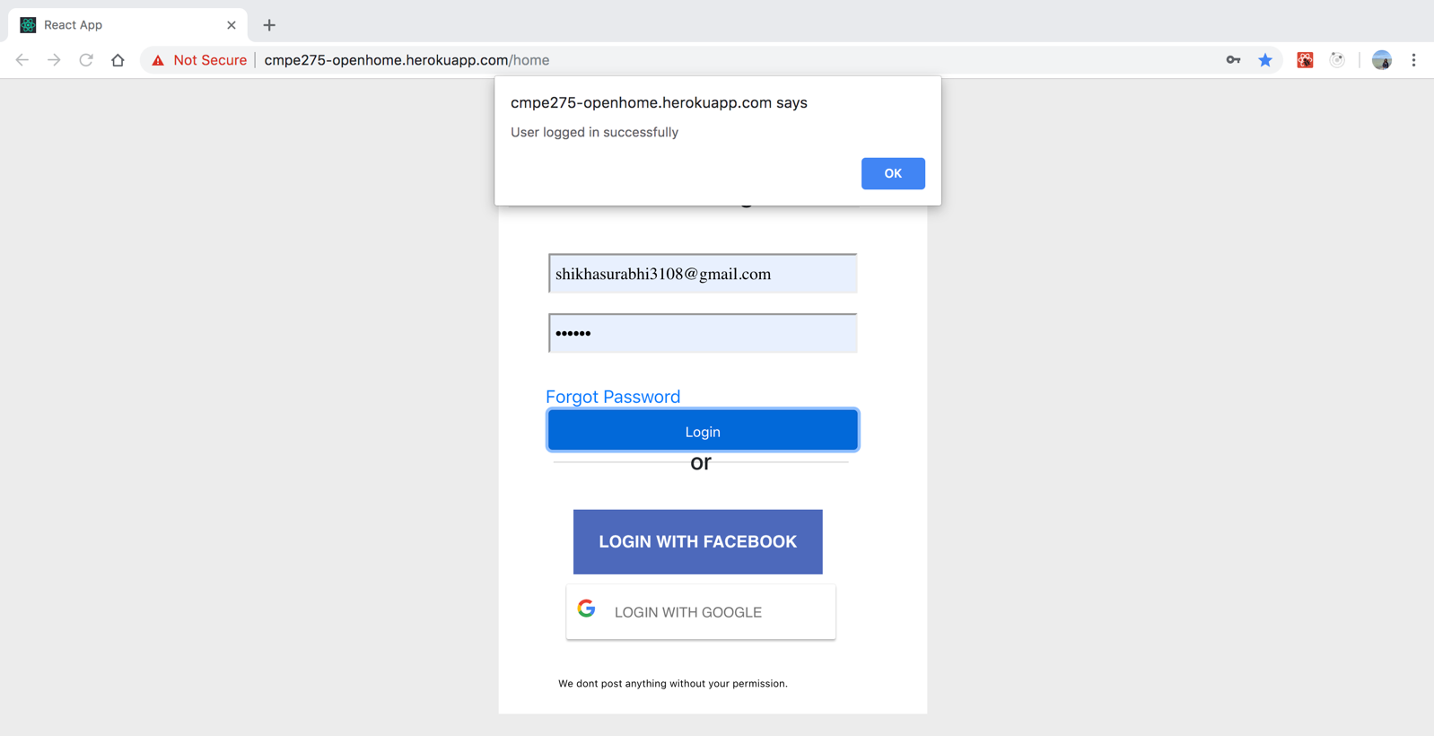

# Property Search Page

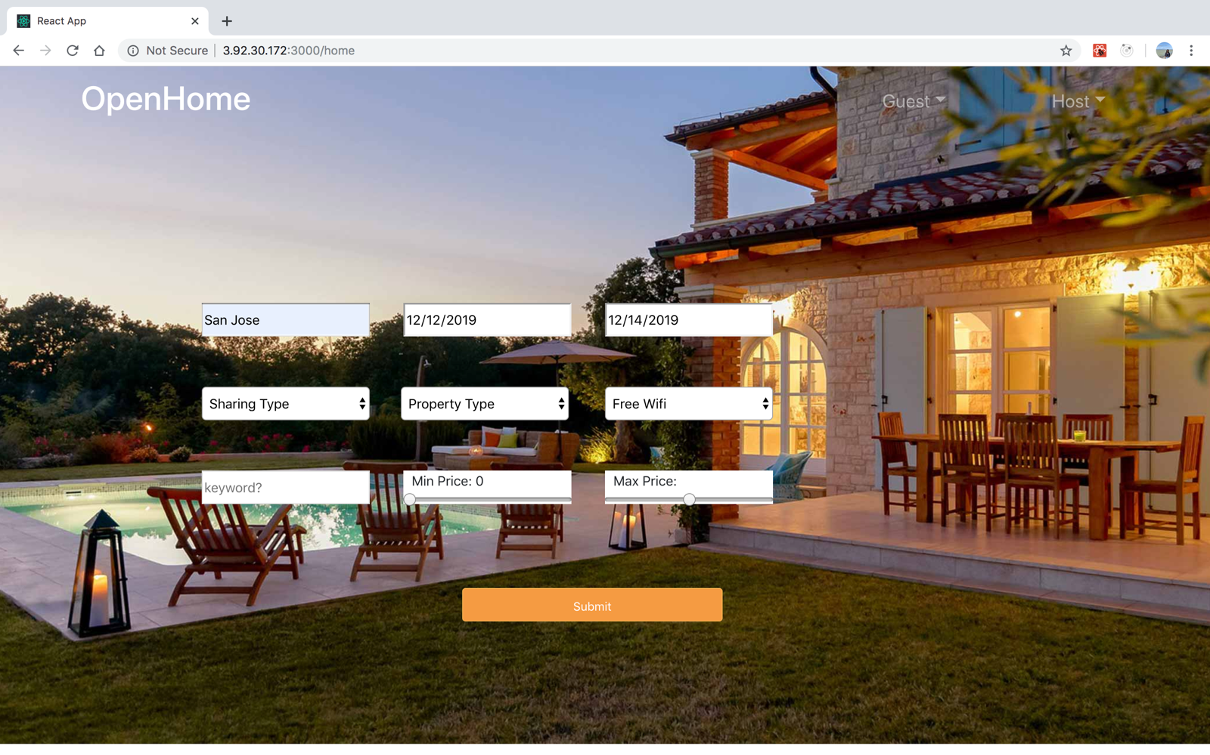

Search Result Page

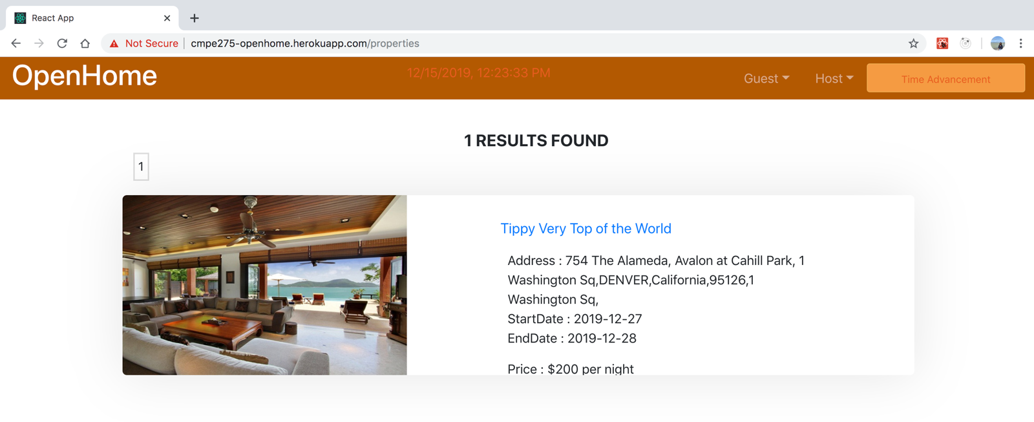

Detailed Property View Page

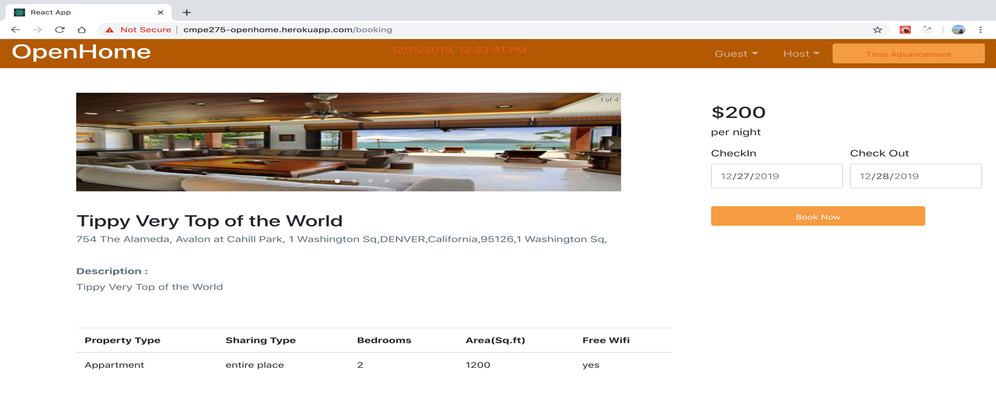

# Book Property

* User can use any saved card or can add card to pay for booking

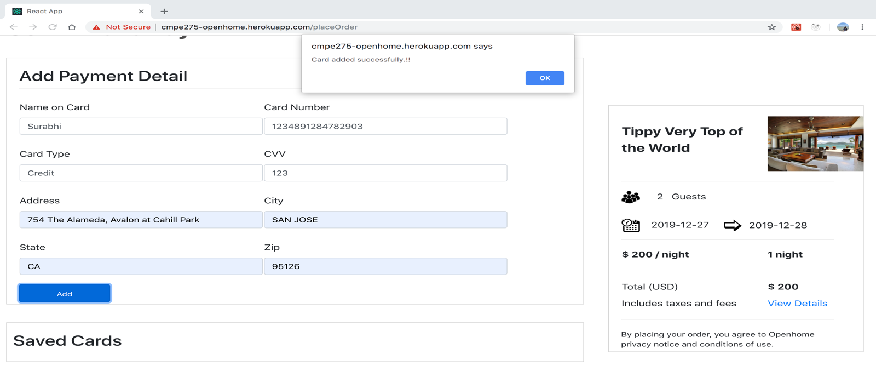

Once card is added, user will get a confirmation mail for card addition:

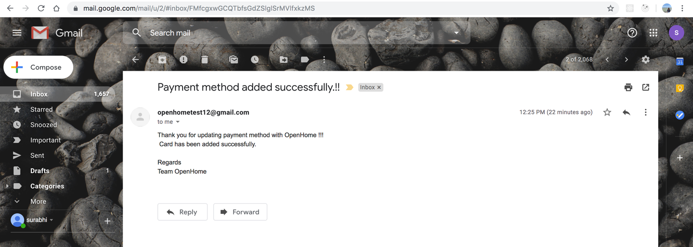

Inserted card will now be available to select for payment:

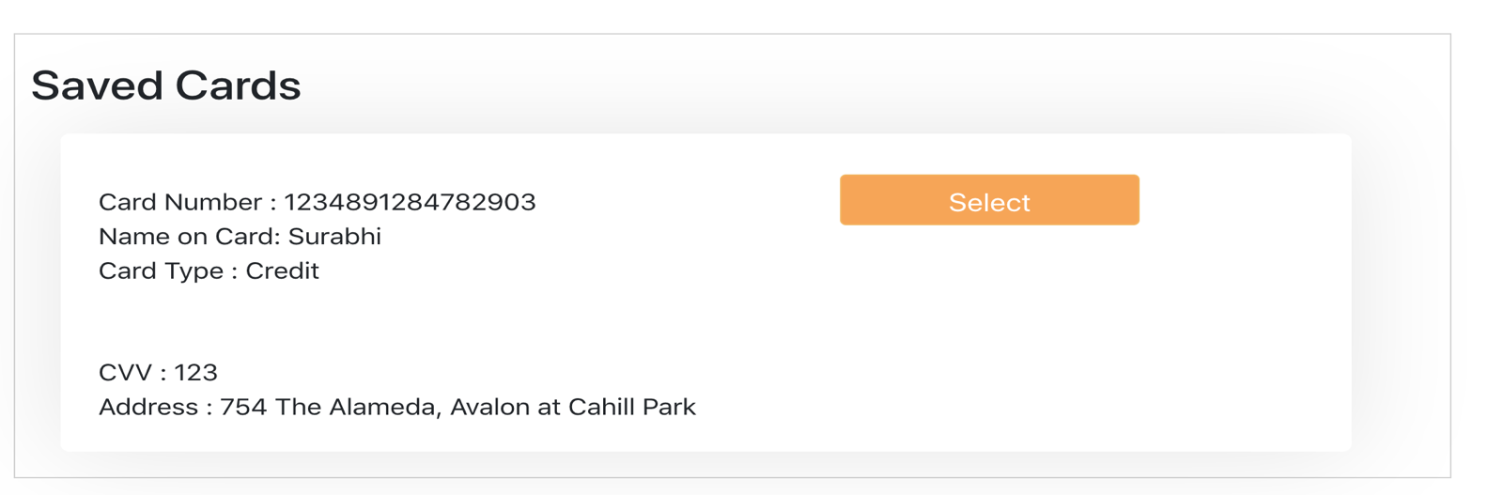

Once user will click “Confirm Booking” , he will be directed to Booking confirmation page and receive a booking confirmation mail :

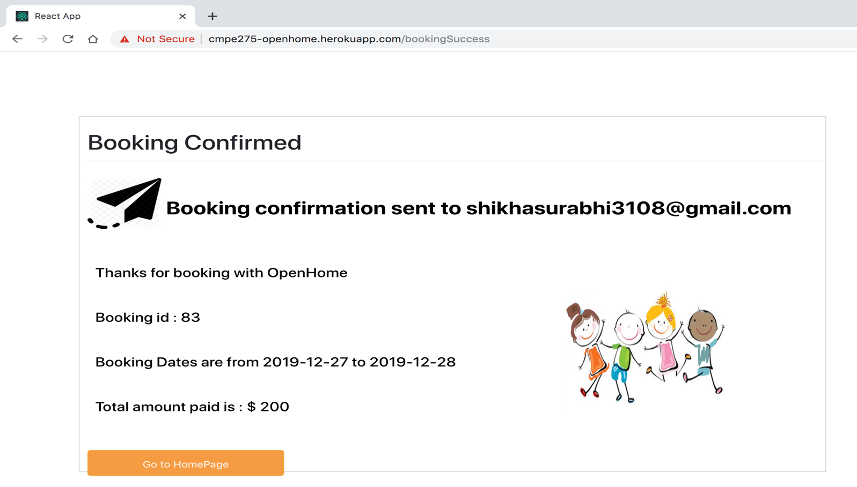

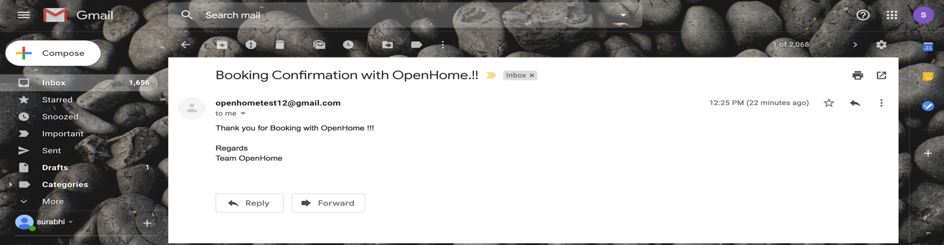

# Guest Dashboard

* User can check-in/check-out/cancel booked property:

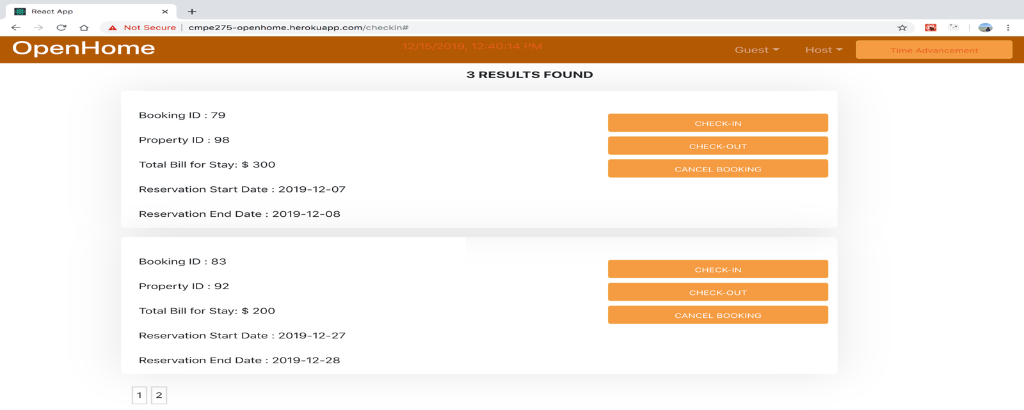

* User can view his booking history from Guest Dashboard for particular month:

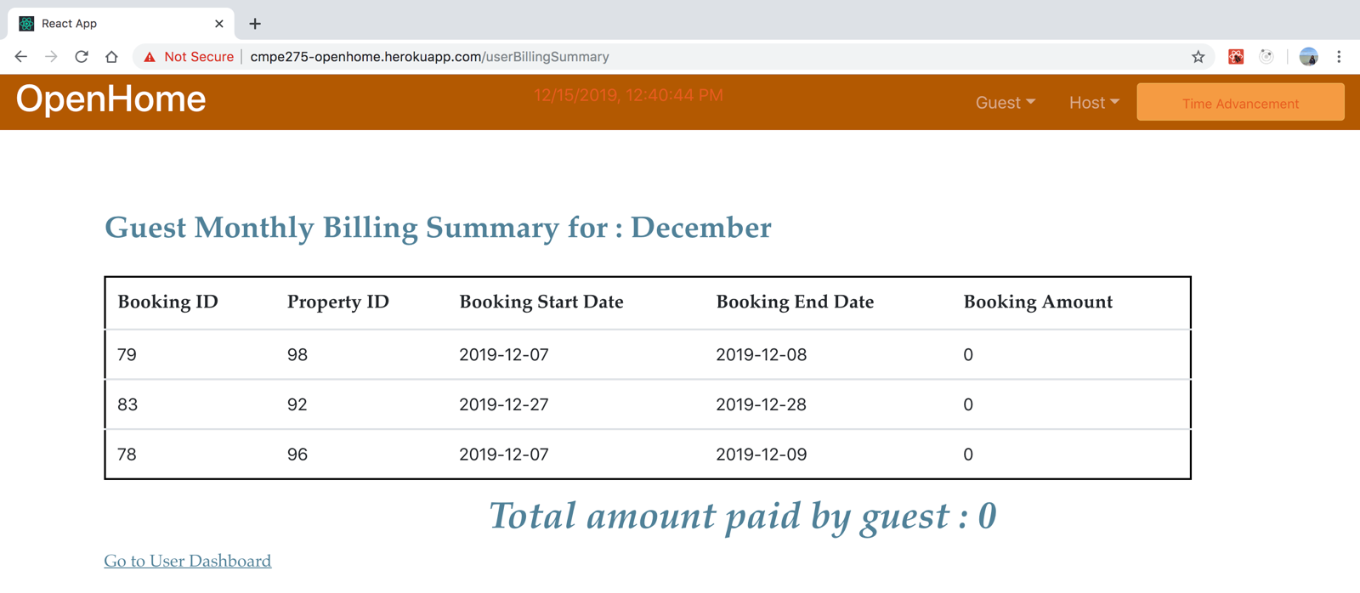

* User can view his booking history from Guest Dashboard for all the months:

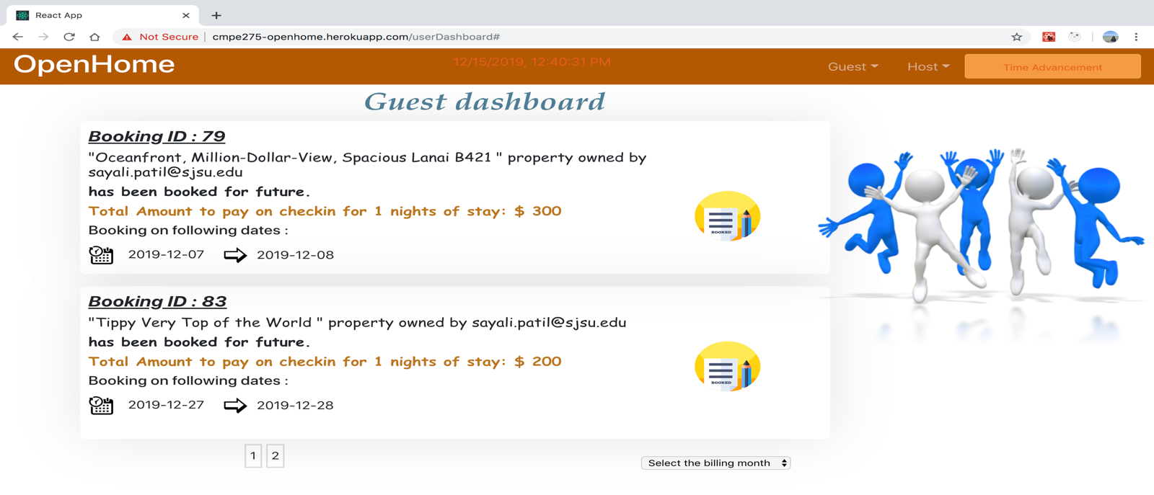

# Property Posting

* Log in as host for posting the property

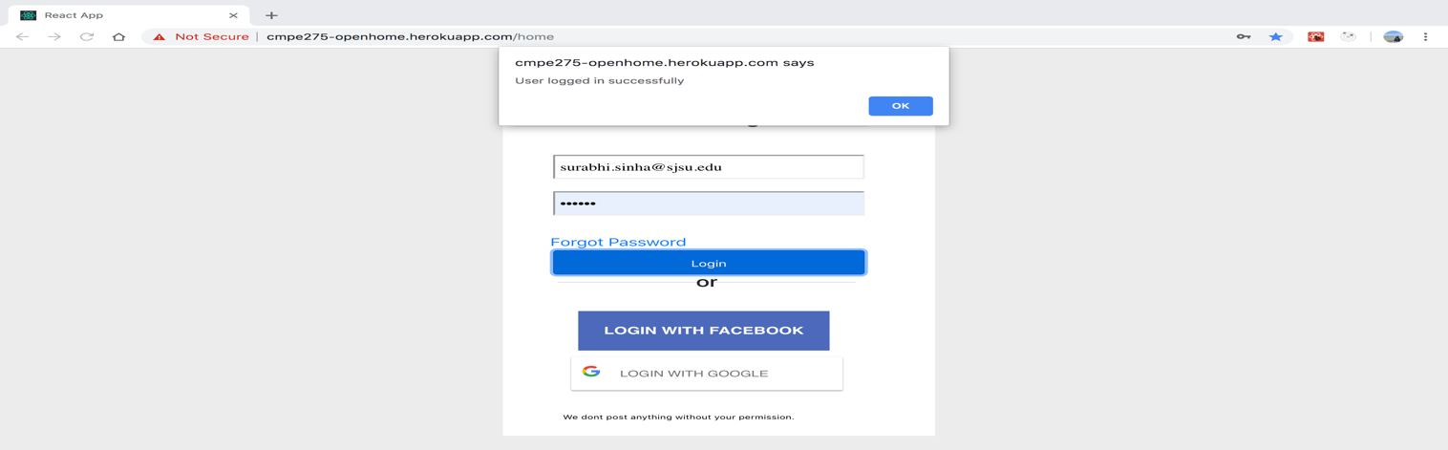

* Post the property

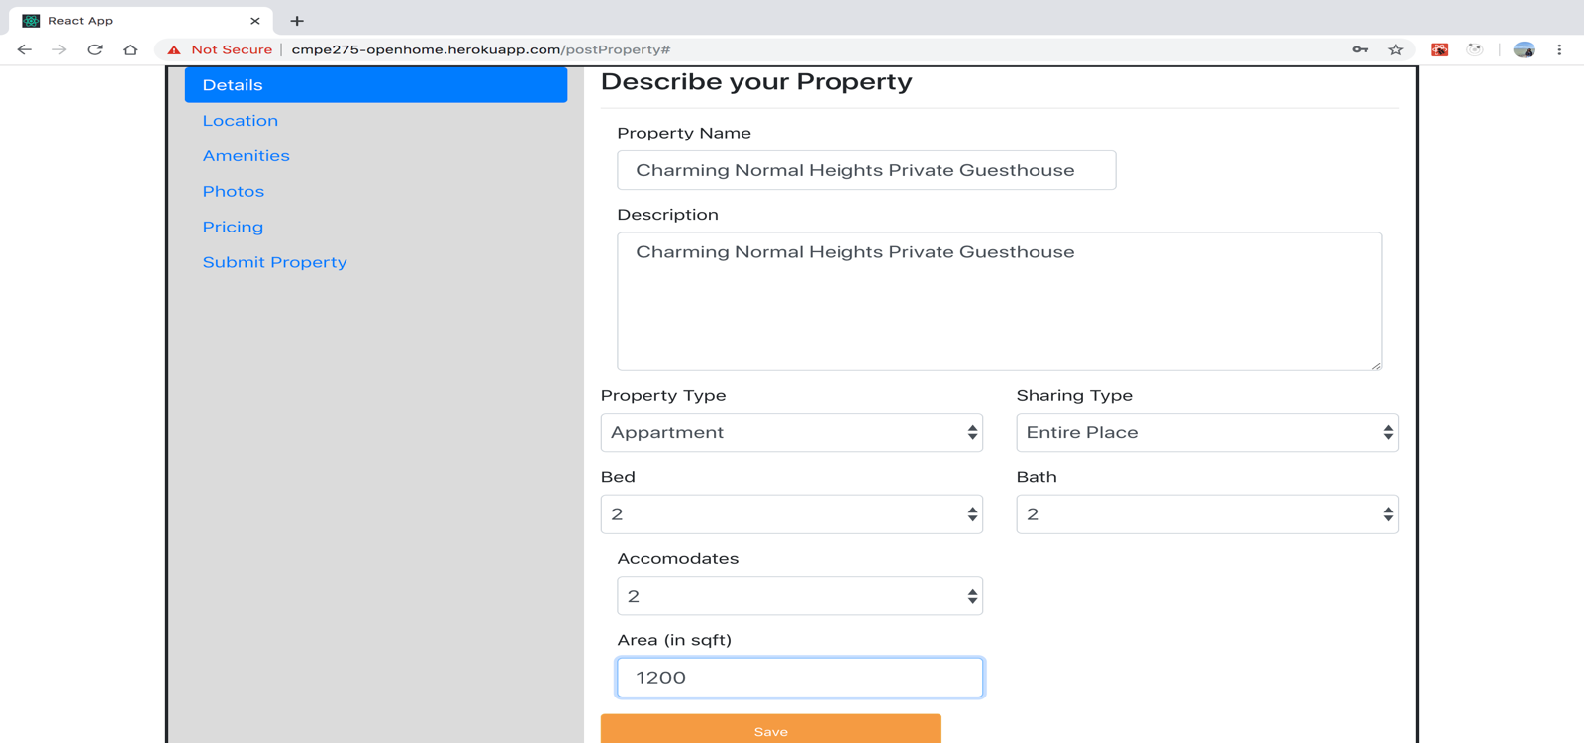

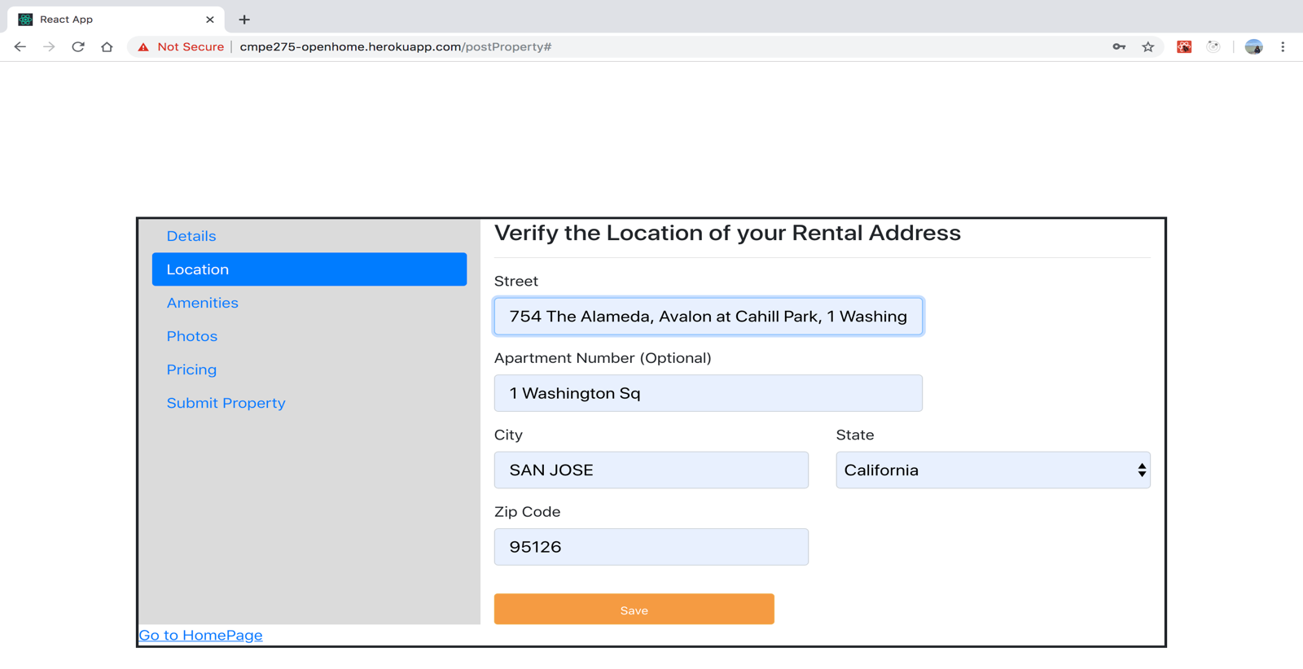

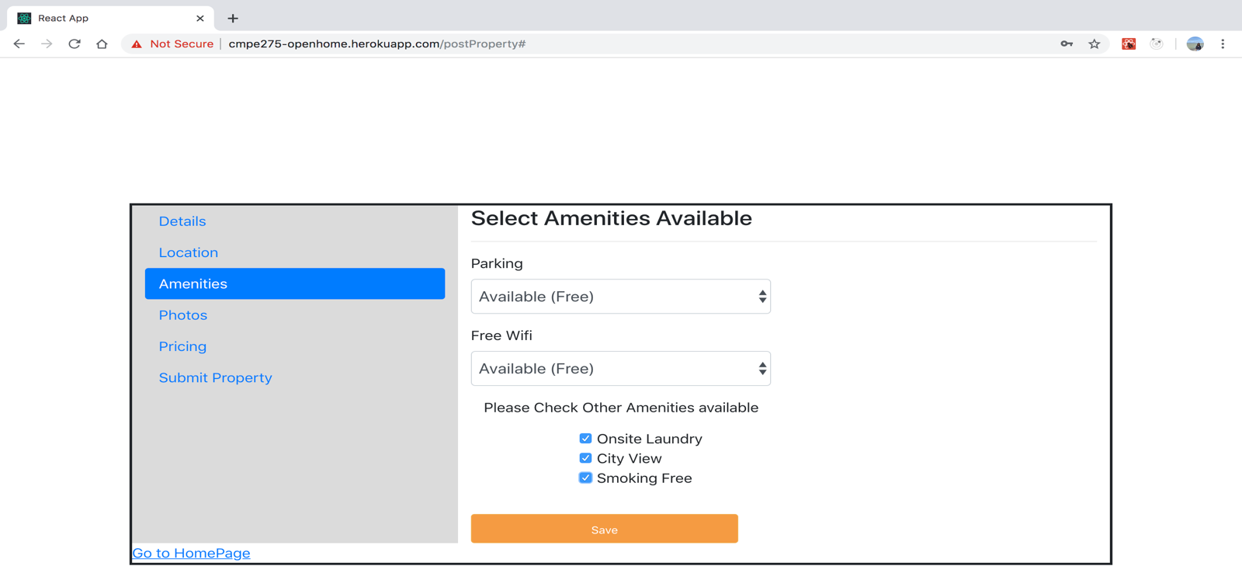

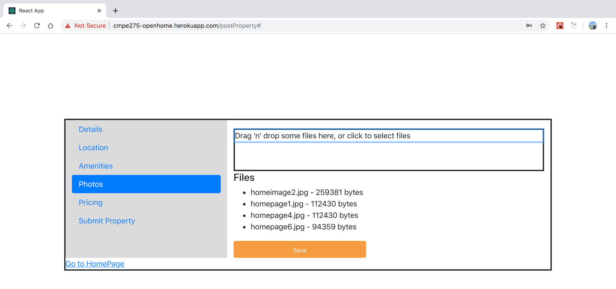

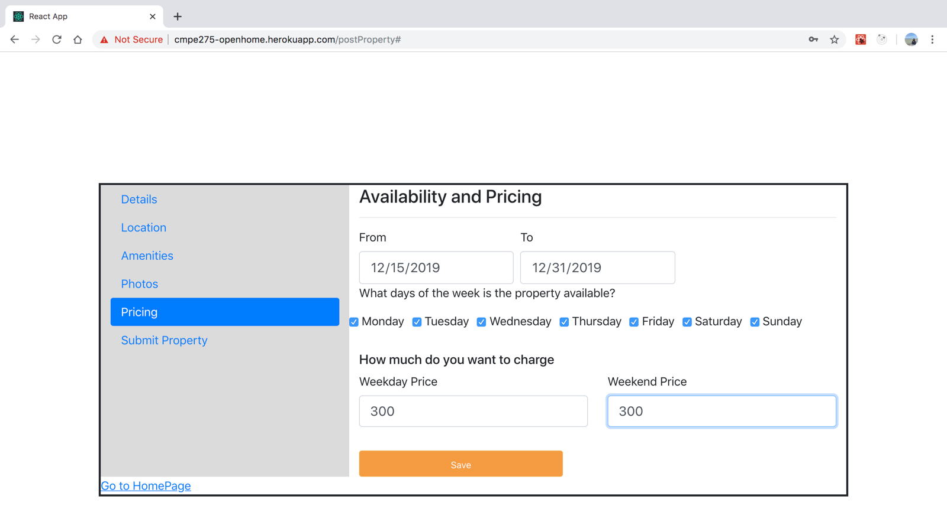

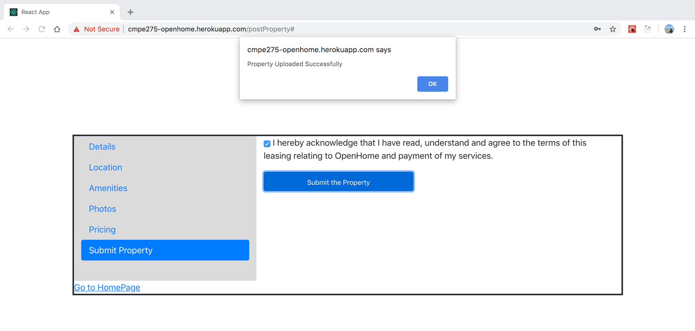

* Property Posting email confirmation:

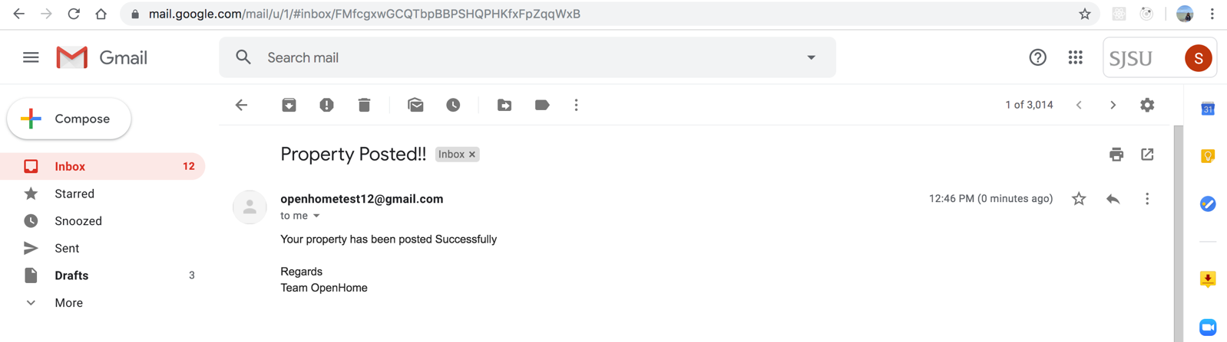

* Editing posted property

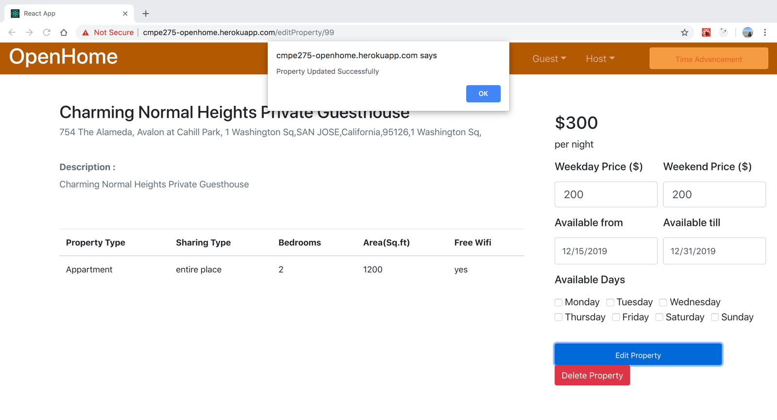

* Host will get confirmation message after updating the property:

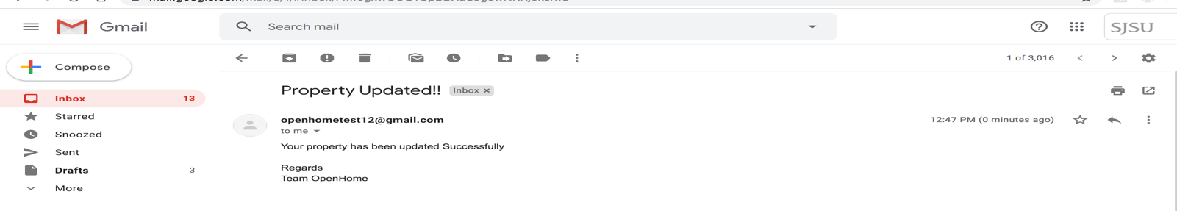

# Host Dashboard

* Host can view his property posted history by property vice

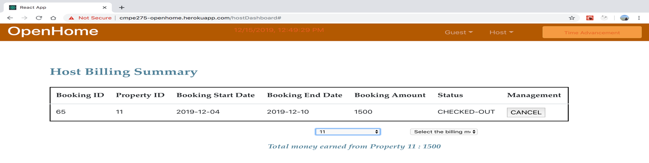

* Host can view his property posted history by property posted month

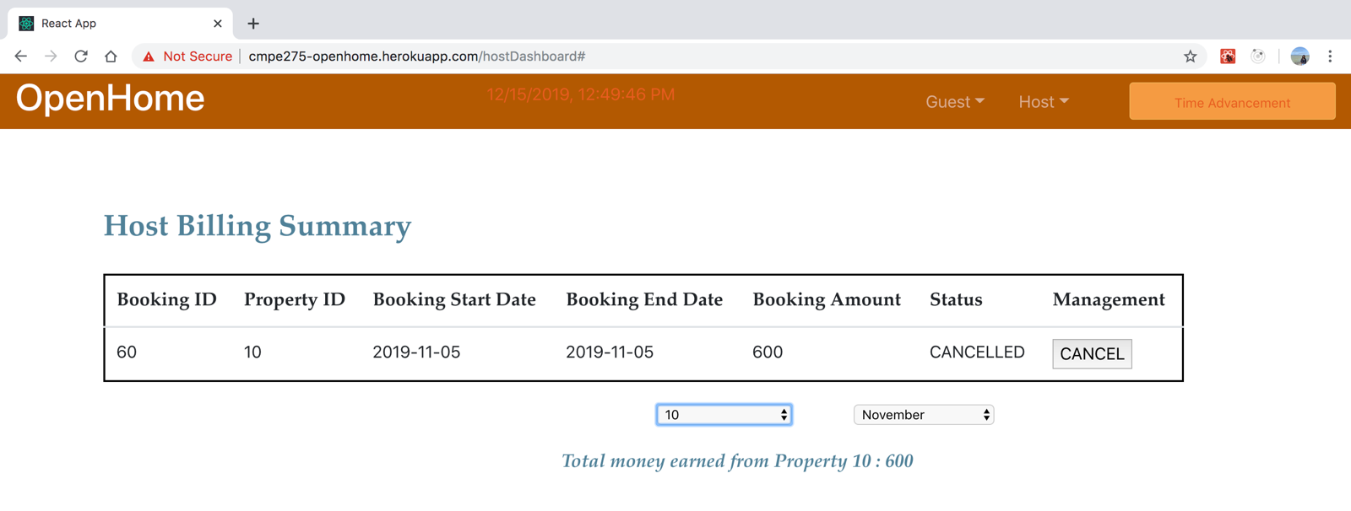

# Testing Plans

# Black-Box Testing

|  |  |  |  |  |
| --- | --- | --- | --- | --- |
| Test No | Test Description | Expected Result | Actual Result | Result |
| 1 | Password Validation | Should not allow passwords shorter than 8 characters | Didn’t allow passwords shorter than 8 characters | Pass |
| 2 | Email Validation | Should not allow invalid email IDs | Didn’t allow invalid email IDs | Pass |
| 3 | Login Button Click | Should be taken to user dashboard | Was taken to user dashboard | Pass |
| 4 | Account Verification | Email with a verification code should be send to given email ID | Email send with a verification code to given email ID | Pas |
| 5 | Logout | Session should be cleared and user should be taken to login page. | Session is cleared and user is taken to login page | Pass |
| 6 | Survey creation | Given survey name, survey type and an optional end date, a new empty survey should be created. | Given a survey name, survey type and an optional end date, survey is created. | Pass |
| 7 | Image Options | Surveyor should be allowed to upload images as options to survey questions | Surveyor is able to upload images as options to survey questions | Pass |
| 8 | Survey Save | Survey can be saved and can be later accessed to continue work from where it was left. | Survey is saved and is accessible to continue work from where it was left | Pass |
| 9 | Survey Publish | Survey should be published and can now be shared with surveyees and surveyees can take the survey | Survey is published and can be now shared with surveyees and surveyees can take the survey | Pass |
| 10 | General Survey Link Share | Invitations to share the survey should be send by email with URL and QR code | Invitations to share the survey is sent by email with URL and QR code | Pass |
| 11 | General survey resubmission by a logged in User | A logged in user cannot take a general survey again | A logged in user cannot take a general survey again | Pass |
| 12 | Closed survey invitation link | Invalidate the link once the closedsurvey is taken. | The link is invalidated when the closed survey is taken | Pass |
| 13 | Invisible unpublished survey | Surveys not yet published cannot be accessed by any user | Surveys not yet published are not accessed by user | Pass |
| 14 | Expired Surveys | Surveys cannot be accessed past their endtime | Surveys are not accessed past their endtime | Pass |
| 15 | General Statistics | Surveyor would be able to see start time, end time, number of participants and participation rate | Surveyor is be able to see start time, end time, number of participants and participation rate | Pass |
| 16 | Questionwise statistics | Surveyor would be able to see number of distribution of each answer choice, all answers provided by surveyees and response rate among total number of submissions. | Surveyor is be able to see number of distribution of each answer choice, all answers provided by surveyees and response rate among total number of submissions. | Pass |
| 17 | Save partially filled surveys | User should be able to logout midway the survey and can take it later | User is able to logout midway and can take the survey later. | Pass |
| 18 | Survey saved on each step | Surveyor’s progress be saved on each step | Surveyor’s progress is saved on each step | Pass |
| 19 | Survey Completion Confirmation email | Surveyee should be send an email confirming reception of response. | Surveyee is sent an email confirming the reception of response. | Pass |
| 20 | Export survey | Survey can be exported in JSON format in a textfile | Survey is exported in JSON format in a textfile | Pass |
| 21 | Import survey | Survey can be imported from a JSON format text | Survey is imported from a JSON format text | Pass |
| 22 | JSON format of survey | Survey JSON be a valid JSON | Survey JSON is a valid JSON | Pass |
| 23 | Append from a survey JSON | Survey from Survey JSON should be appended into a current survey | Survey from survey JSON can be appended into a current survey | Pass |
| 24 | Survey access | Surveyee with or without an account should access survey. | Surveyee with or without account do access survey | Pass |
| 25 | Single account for Surveyor and Surveyee | A user should be able to assume roles of surveyor and surveyee from a single account | A user is able to assume roles of surveyor and surveyee from a single account | Pass |

# Server Unit Testing

|  |  |  |  |  |
| --- | --- | --- | --- | --- |
| Test No | Test Description | Expected Result | Actual Result | Result |
| 1 | Testing User Sign up | {"userId":"123456","email":"test_user@gmail.com","firstname":"Sannisth","lastname":"Soni","verified":true} | {"userId":"123456","email":"test_user@gmail.com","firstname":"Sannisth","lastname":"Soni","verified":true} | Pass |
| 2 | Validating Session | {"userId":"123456","email":"test_user@gmail.com","firstname":"Sannisth","lastname":"Soni","verified":true} | {"userId":"123456","email":"test_user@gmail.com","firstname":"Sannisth","lastname":"Soni","verified":true} | Pass |
| 3 | Verifying Account | {"message":"User successfully verified."} | {"message":"User successfully verified."} | Pass |
| 4 | Testing User Login | {"userId":"123456","email":"test_user@gmail.com","firstname":"Sannisth","lastname":"Soni","verified":true} | {"userId":"123456","email":"test_user@gmail.com","firstname":"Sannisth","lastname":"Soni","verified":true} | Pass |
| 5 | Creating a new Survey | {"survey_id":"123456","survey_name":"Survey1","survey_type":"general","creation_date":"2018-01-01T08:00:00.000+0000","update_date":"2018-01-01T08:00:00.000+0000","publish_date":"2018-01-01T08:00:00.000+0000","ispublished":true,"iseditable":true,"end_date":"2018-01-01T08:00:00.000+0000","email":{"email":"test_user@gmail.com"},"questions":[{"isMultipleChoice":false,"options":[],"question_id":"123456","question_type":"MultipleChoiceQuestion","question_text":"How many more Apples are there than oranges?"}],"survey_responses":[{}]} | {"survey_id":"123456","survey_name":"Survey1","survey_type":"general","creation_date":"2018-01-01T08:00:00.000+0000","update_date":"2018-01-01T08:00:00.000+0000","publish_date":"2018-01-01T08:00:00.000+0000","ispublished":true,"iseditable":true,"end_date":"2018-01-01T08:00:00.000+0000","email":{"email":"test_user@gmail.com"},"questions":[{"isMultipleChoice":false,"options":[],"question_id":"123456","question_type":"MultipleChoiceQuestion","question_text":"How many more Apples are there than oranges?"}],"survey_responses":[{}]} | Pass |
| 6 | Fetch Survey | {"survey_id":"123456","survey_name":"Survey1","survey_type":"general","creation_date":"2018-01-01T08:00:00.000+0000","update_date":"2018-01-01T08:00:00.000+0000","publish_date":"2018-01-01T08:00:00.000+0000","ispublished":true,"iseditable":true,"end_date":"2018-01-01T08:00:00.000+0000","email":{"email":"test_user@gmail.com"},"questions":[{"isMultipleChoice":false,"options":[],"question_id":"123456","question_type":"MultipleChoiceQuestion","question_text":"How many more Apples are there than oranges?"}],"survey_responses":[{}]} | {"survey_id":"123456","survey_name":"Survey1","survey_type":"general","creation_date":"2018-01-01T08:00:00.000+0000","update_date":"2018-01-01T08:00:00.000+0000","publish_date":"2018-01-01T08:00:00.000+0000","ispublished":true,"iseditable":true,"end_date":"2018-01-01T08:00:00.000+0000","email":{"email":"test_user@gmail.com"},"questions":[{"isMultipleChoice":false,"options":[],"question_id":"123456","question_type":"MultipleChoiceQuestion","question_text":"How many more Apples are there than oranges?"}],"survey_responses":[{}]} | Pass |
| 7 | Updating a survey | {"survey_id":"123456","survey_name":"Survey1","survey_type":"general","creation_date":"2018-01-01T08:00:00.000+0000","update_date":"2018-01-01T08:00:00.000+0000","publish_date":"2018-01-01T08:00:00.000+0000","ispublished":true,"iseditable":true,"end_date":"2018-01-01T08:00:00.000+0000","email":{"email":"test_user@gmail.com"},"questions":[{"isMultipleChoice":false,"options":[],"question_id":"123456","question_type":"MultipleChoiceQuestion","question_text":"How many more Apples are there than oranges?"}],"survey_responses":[{}]} | {"survey_id":"123456","survey_name":"Survey1","survey_type":"general","creation_date":"2018-01-01T08:00:00.000+0000","update_date":"2018-01-01T08:00:00.000+0000","publish_date":"2018-01-01T08:00:00.000+0000","ispublished":true,"iseditable":true,"end_date":"2018-01-01T08:00:00.000+0000","email":{"email":"test_user@gmail.com"},"questions":[{"isMultipleChoice":false,"options":[],"question_id":"123456","question_type":"MultipleChoiceQuestion","question_text":"How many more Apples are there than oranges?"}],"survey_responses":[{}]} | Pass |
| 8 | DeleteOption | {"survey_id":"123456","survey_name":"Survey1","survey_type":"general","creation_date":"2018-01-01T08:00:00.000+0000","update_date":"2018-01-01T08:00:00.000+0000","publish_date":"2018-01-01T08:00:00.000+0000","ispublished":false,"iseditable":true,"end_date":"2018-01-01T08:00:00.000+0000","email":{"email":"test_user@gmail.com"},"questions":[{"isMultipleChoice":false,"options":[],"question_id":"123456","question_type":"MultipleChoiceQuestion","question_text":"How many more Apples are there than oranges?"}],"survey_responses":[{}]} | {"survey_id":"123456","survey_name":"Survey1","survey_type":"general","creation_date":"2018-01-01T08:00:00.000+0000","update_date":"2018-01-01T08:00:00.000+0000","publish_date":"2018-01-01T08:00:00.000+0000","ispublished":false,"iseditable":true,"end_date":"2018-01-01T08:00:00.000+0000","email":{"email":"test_user@gmail.com"},"questions":[{"isMultipleChoice":false,"options":[],"question_id":"123456","question_type":"MultipleChoiceQuestion","question_text":"How many more Apples are there than oranges?"}],"survey_responses":[{}]} | Pass |
| 9 | Share Survey | {"message":"Survey shared successfully !!!"} | {"message":"Survey shared successfully !!!"} | Pass |
| 10 | Publish Survey | {"message":"Survey published successfully !!!"} | {"message":"Survey published successfully !!!"} | Pass |
| 11 | Close Survey | {"end_date":"2018-05-20T00:26:32.703+0000"} | {"end_date":"2018-05-20T00:26:32.703+0000"} | Pass |
| 12 | Save End Survey | {"end_date":"2018-05-20T00:28:07.273+0000"} | {"end_date":"2018-05-20T00:28:07.273+0000"} | Pass |
| 13 | Upload Question | {"survey_id":"123456","survey_name":"Survey1","survey_type":"general","creation_date":"2018-01-01T08:00:00.000+0000","update_date":"2018-01-01T08:00:00.000+0000","publish_date":"2018-01-01T08:00:00.000+0000","ispublished":true,"iseditable":true,"end_date":"2018-01-01T08:00:00.000+0000","email":{"email":"test_user@gmail.com"},"questions":[{"isMultipleChoice":false,"options":[],"question_id":"123456","question_type":"MultipleChoiceQuestion","question_text":"How many more Apples are there than oranges?"}],"survey_responses":[{}]} | {"survey_id":"123456","survey_name":"Survey1","survey_type":"general","creation_date":"2018-01-01T08:00:00.000+0000","update_date":"2018-01-01T08:00:00.000+0000","publish_date":"2018-01-01T08:00:00.000+0000","ispublished":true,"iseditable":true,"end_date":"2018-01-01T08:00:00.000+0000","email":{"email":"test_user@gmail.com"},"questions":[{"isMultipleChoice":false,"options":[],"question_id":"123456","question_type":"MultipleChoiceQuestion","question_text":"How many more Apples are there than oranges?"}],"survey_responses":[{}]} | Pass |

* UserControllerTest

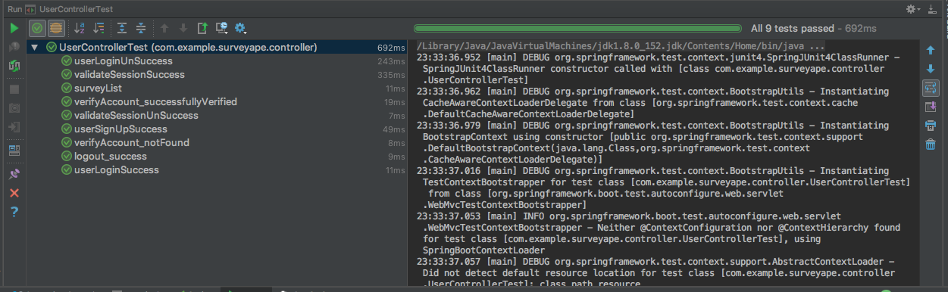

* SurveyResponseControllerTest

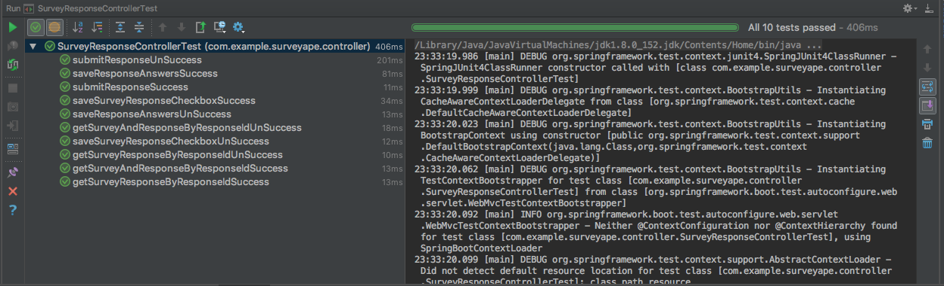

* SurveyControllerTest

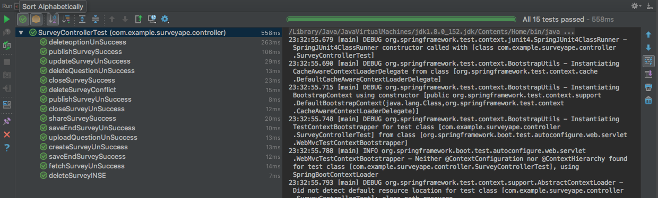

* StatisticControllerTest

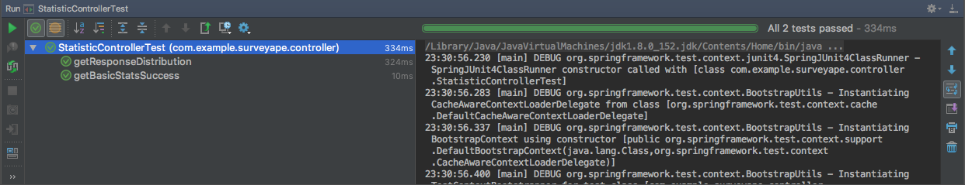

# Retrospect and Future Enhancements

**Retrospection**

* A Robust database and architecture design helped in easy integration of changes and/or additions in requirements during development.
* Use of SCM (here git) helped manage and share code better and allowed for retreating to an earlier stable version of code whenever needed.
* Using RDS instance for database from start during the development proved to be beneficial having centralized database on cloud for each user.
* Regular team members status update could have helped team to achieve goal faster and with less difficulties.

**Future Enhancements**

* We can add load balancing and auto scaling of AWS to deploy application
* We can use NoSQL database like MongoDB, which will be a perfect fit for database trying to store data about questions with variety of question and option types (in key-value JSON format).
* Spring security can be used to make application more secure.
* Insights on users’ utilization can be gathered using kibana and application can be modified according to them
* Request Caching can be done using Redis for faster response
* Deployment can be done by dockerizing client and server

# Github URL

<https://github.com/surabhisinha31/cmpe275-OpenHome>

# Application URL

<http://ec2-34-217-100-19.us-west-2.compute.amazonaws.com:3000/>